Assignment – 07
Insert Commands
1. Write a SQL statement to insert a record with your own value into the table countries against each column.
Here in the following is the structure of the table countries.
+--------------+---------------+------+-----+---------+-------+
| Field | Type | Null | Key | Default | Extra |
+--------------+---------------+------+-----+---------+-------+
| COUNTRY_ID | varchar(2) | YES | | NULL | |
| COUNTRY_NAME | varchar(40) | YES | | NULL | |
| REGION_ID | decimal(10,0) | YES | | NULL | |
+--------------+---------------+------+-----+---------+-------+
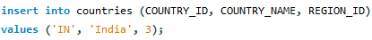

2. Write a SQL statement to insert one row into the table countries against the column country_id and country_name.
Here in the following is the structure of the table countries.
+--------------+---------------+------+-----+---------+-------+
| Field | Type | Null | Key | Default | Extra |
+--------------+---------------+------+-----+---------+-------+
| COUNTRY_ID | varchar(2) | YES | | NULL | |
| COUNTRY_NAME | varchar(40) | YES | | NULL | |
| REGION_ID | decimal(10,0) | YES | | NULL | |
+--------------+---------------+------+-----+---------+-------+


3. Write a SQL statement to create duplicate of countries table named country_new with all structure and data.
Here in the following is the structure of the table countries.
+--------------+---------------+------+-----+---------+-------+
| Field | Type | Null | Key | Default | Extra |
+--------------+---------------+------+-----+---------+-------+
| COUNTRY_ID | varchar(2) | YES | | NULL | |
| COUNTRY_NAME | varchar(40) | YES | | NULL | |
| REGION_ID | decimal(10,0) | YES | | NULL | |
+--------------+---------------+------+-----+---------+-------+

4. Write a SQL statement to insert NULL values against the region_id column for a row of countries table.
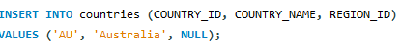
5. Write a SQL statement to insert 3 rows by a single insert statement.
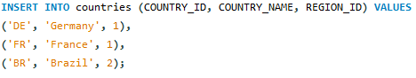
6. Write a SQL statement insert rows from country_new table to countries table.
Here are the rows for the country_new table. Assume that the country's table is empty.
+------------+--------------+-----------+
| COUNTRY_ID | COUNTRY_NAME | REGION_ID |
+------------+--------------+-----------+
| C0001 | India | 1001 |
| C0002 | USA | 1007 |
| C0003 | UK | 1003 |
+------------+--------------+-----------+


7. Write a SQL statement to insert one row in jobs table to ensure that no duplicate value will be entered in the job_id column.

8. Write a SQL statement to insert one row in jobs table to ensure that no duplicate value will be entered in the job_id column.
9. Write a SQL statement to insert a record into the table countries to ensure that, a country_id and region_id combination will be entered once in the table.
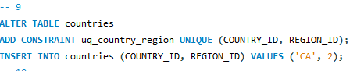
10. Write a SQL statement to insert rows into the table countries in which the value of country_id column will be unique and auto incremented.
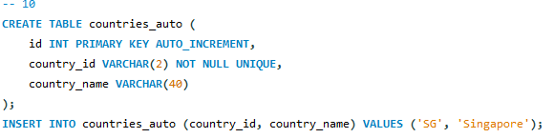
11. Write a SQL statement to insert records into the table countries to ensure that the country_id column will not contain any duplicate data and this will be automatically incremented and the column country_name will be filled up by 'N/A' if no value assigned for that column.
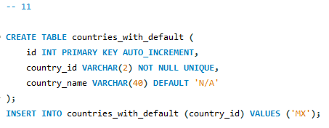
12. Write a SQL statement to insert rows in the job_history table in which one column job_id is containing those values which are exists in job_id column of jobs table.
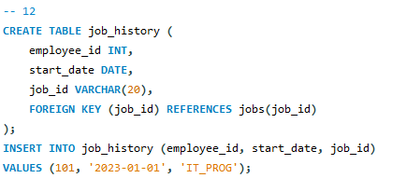
13. Write a SQL statement to insert rows into the table employees in which a set of columns department_id and manager_id contains a unique value and that combined values must have existed into the table departments.
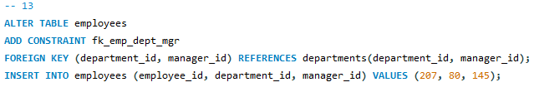
14. Write a SQL statement to insert rows into the table employees in which a set of columns department_id and job_id contains the values which must have exists into the table departments and jobs.
